Prior Knowledge Review – Human Interaction
- Use the following food web to answer the questions:
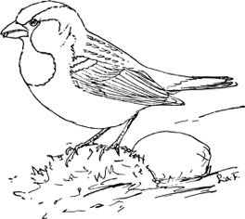
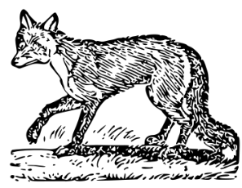
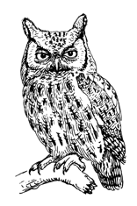
Owl
Sparrow
Fox

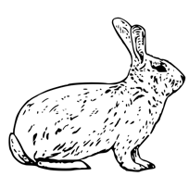
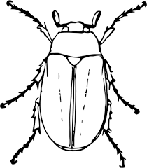
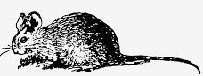
Mouse
Rabbit
Beetle

Lettuce
Seeds
Grass
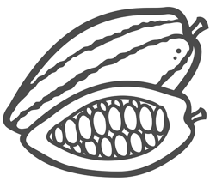
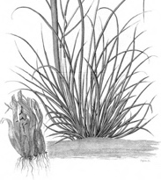
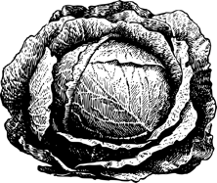

- Identify any producers (circle the name of the species in green).

- Identify any primary consumers (circle the name of the species in blue).

- Identify any secondary consumers (circle the name of the species in black).

- Identify any predators (put a black dot next to the name of the species).

- Identify any prey (put a blue dot next to the name of the species).

- Determine which species are herbivores (draw a square around the name of the species).

- Determine which species are carnivores (draw a triangle around the name of the species).
- Describe what would happen if the population of rabbits was suddenly reduced.
_______________________________________________________________________________________________
_______________________________________________________________________________________________
_______________________________________________________________________________________________
_______________________________________________________________________________________________

- Describe the effects of introducing a new species of sparrow into this food web.

_______________________________________________________________________________________________
_______________________________________________________________________________________________
_______________________________________________________________________________________________
_______________________________________________________________________________________________

- Explain what the arrows represent in a food chain or a food web.

_______________________________________________________________________________________________
_______________________________________________________________________________________________

